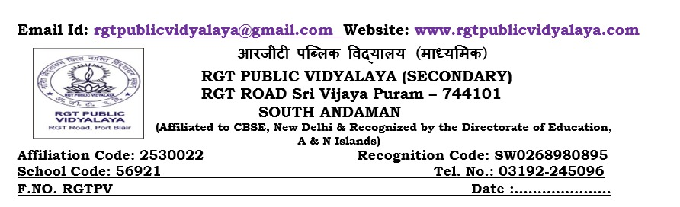
Date : 31/07/2026
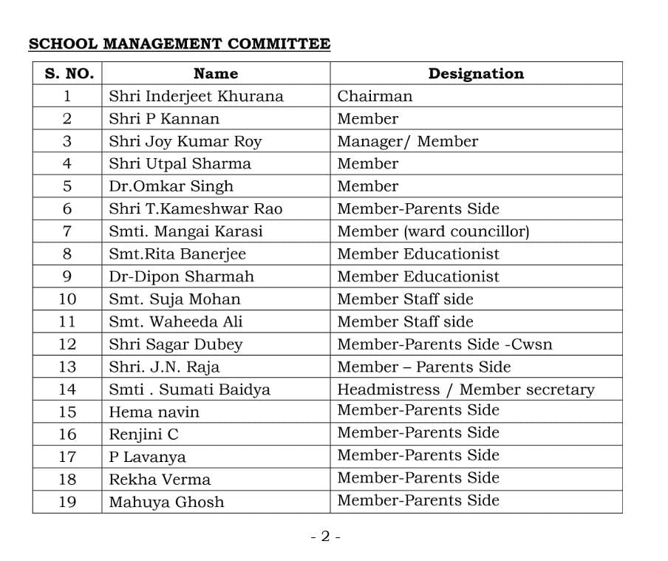

Sd/-
Headmistress
RGT Public Vidyalaya

