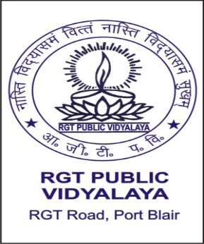
Mail Id: rgtpublicvidyalaya@gmail.com Website: www.rgtpublicvidyalaya.com
RGT PUBLIC VIDYALAYA (SECONDARY)
RGT ROAD, SRI VIJAYA PURAM – 744101
SOUTH ANDAMAN
(Affiliated to CBSE, New Delhi & Recognized by the
Directorate of Education, A & N Islands)
Affiliation Code: 2530022

SESSION 2024-25
PARENTS TEACHER ASSOCIATION
SL.NO | NAME | DESIGNATION
1 | MRS . SUMATI BAIDYA , HM (SS) | CHAIRMAN
2 | SHRI. KAMESHWAR RAO (PARENTS) | SECRETARY
3 | SMTI. N. POOWATHI (PARENTS) | EXECUTIVE MEMBER
4 | SHRI. KRISHNA (PARENT) | DO
5 | SHRI. DIPON SHARMAH (PARENT) | DO
6 | SMTI. SUJA MOHAN (GTT) | DO
7 | SMTI. WAHEEDA ALI (GTT) | DO
8 | SHRI. NITISH MAZUMDER (P.ET) | DO
9 | ALL PARENTS OF BONAFIDE STUDENTS | MEMBERS

