Mail Id: rgtpublicvidyalaya@gmail.com Website: www.rgtpublicvidyalaya.com

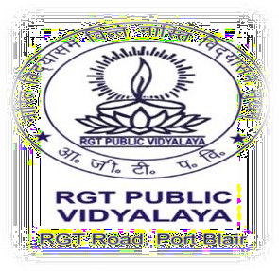
RGT PUBLIC VIDYALAYA (SECONDARY)
RGT ROAD, Sri Vijaya Puram – 744101 SOUTH ANDAMAN
(Affiliated to CBSE, New Delhi & Recognized by the Directorate of Education, A & N Islands)
Affiliation Code: 2530022
School Code: 56921 Tel. No.: 03192-238652

CBSE BOARD RESULT CLASS X

Session - 2020-21, 2021-22, 2022-23, 2023-24,2024-25,2025-26

SL.NO | YEAR | NO. OF REGISTERED STUDENTS | NO. OF STUDENTS PASSED | NO. OF STUDENTS PLACED FOR COMPARTMENT | NO OF STUDENTS ABSENT | PASS PERCENTAGE | REMARKS
1 | 2020-21 | 10 | 10 | 0 | 0 | 100 % | 1ST BATCH
2 | 2021-22 | 21 | 19 | 02 | 0 | 90.47 | 2ND BATCH
3 | 2022-23 | 16 | 11 | 04 | 01 | 69% | 3RD BATCH
4. | 2023-24 | 27 | 27 | 00 | 00 | 100 % | 4TH BATCH
5. | 2024-25 | 19 | 19 | 00 | 00 | 100% | 5TH BATCH
6. | 2025-26 | 14 | 14 | 00 | 00 | 100% | 6TH BATCH
